Turnkey Product Development & Regulatory Consultancy Services
At Revive Medical Technologies (RMT), we provide comprehensive turnkey product development and regulatory consulting services for medical devices. Our expertise covers the complete development lifecycle of vascular intervention and minimally invasive devices, including stents, PTCA balloon catheters, PTA balloon catheters, guide catheters, angiographic catheters, introducer sheaths, inflation devices, and other disposable medical devices.
We offer end-to-end product realization solutions, enabling our clients to focus on commercialization while we manage the technical, manufacturing, quality, and regulatory aspects of development.
1. Concept Development & Feasibility
- User needs and market assessment
- Defining Design input
- Technical feasibility studies
- Material selection
- Risk assessment
- Commercial viability evaluation
2. Product Design & Engineering
- Product architecture development
- Mechanical design and CAD modeling
- Design optimization
- Engineering analysis and simulations
- Design for Manufacturability (DFM)
3. Prototyping & Development
- Rapid prototyping
- Functional prototype development
- Process development
- Design refinement and optimization
- Packaging development
- Manufacturing feasibility assessment
4. Verification & Validation
- Design verification testing
- Functional and performance evaluation
- Reliability and durability testing
- Usability assessments
- Packaging validation
- Sterilization validation support
- Risk management activities
5. Design Transfer & Manufacturing Support
- Manufacturing process development
- Production documentation
- Assembly and inspection procedures
- Process validation support
- Supplier qualification
- Technology transfer
- Production scale-up support
6. Regulatory & Quality Consultancy
- ISO 13485 implementation
- ISO 14971 risk management
- Design control compliance
- Technical documentation preparation
- Validation services (IQ/OQ/PQ)
- Product registration support
- Regulatory strategy and submissions

Metric | Description
15+ | Products Developed & Delivered
50+ | Regulatory Standards & Frameworks
6+ | Product Development Lifecycle Stages
15+ | Years Combined Industry Experience
End-to-End | Turnkey Development Services

Compliance & Standards
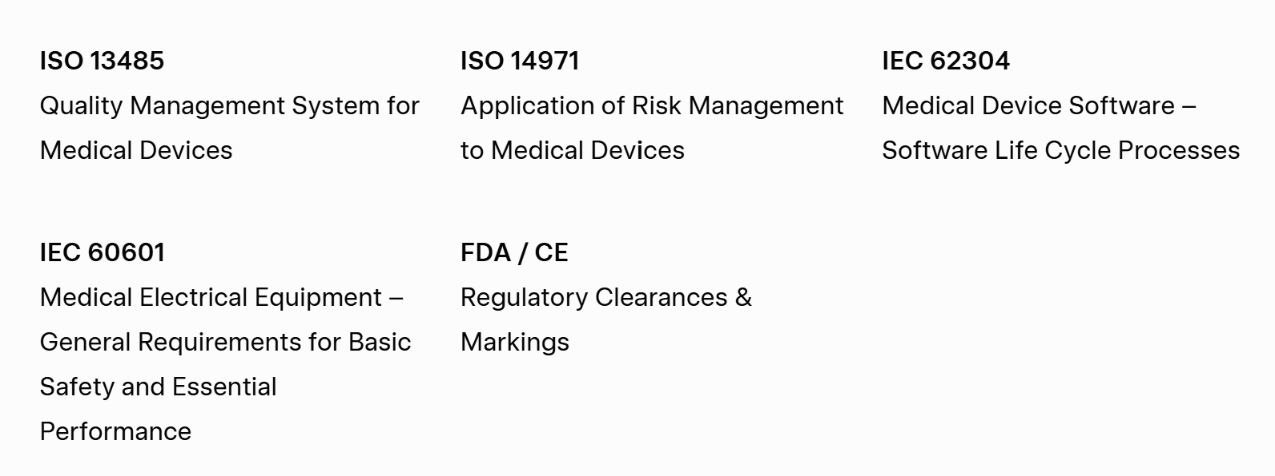
Add DRAP as well along with FDA/CE

Core Capabilities
- Turnkey Product Development — Complete product realization from idea to market
- Design & Engineering — CAD, simulations, and DFM expertise
- Prototyping to Validation — Rapid prototypes, testing & regulatory-ready documentation
- Regulatory Excellence — ISO, FDA, CE, and global compliance support

Product Development Lifecycle
Link Phase explanation with tile via some arrow etc to make it visually better

Turnkey Manufacturing Solutions->Turnkey Manufacturing Consultancy Solutions
- Manufacturing Line Setup
Design and implementation of efficient, GMP-compliant production lines tailored for medical devices.
- Production Process Development
Optimization of manufacturing processes for quality, efficiency, repeatability, and cost-effectiveness.
- Vendor & Supplier Qualification
Identification, evaluation, auditing, and qualification of reliable suppliers and contract manufacturers.
- Production Equipment Selection
Strategic selection, qualification, and validation of manufacturing equipment and tooling.
- Quality Control System Implementation
Development and deployment of robust quality management systems aligned with ISO 13485.
- Manufacturing Documentation
Creation of complete, audit-ready production documentation, work instructions, SOPs, and quality records.
- Staff Training & Technology Transfer
Comprehensive training programs and smooth knowledge transfer to your internal manufacturing team.

